**Testbench for Encryption:**

module tb_aes();

reg [127:0] data_in;

reg [127:0] key;

wire [127:0] data_out;

AES_encryption g1(.data_out(data_out),.data_in(data_in),.key(key));

initial begin

data_in=128'h_33333333_bbbbbbbb_aaaaaaaa_99999999;

key = 128'h_2b7e1516_28aed2a6_abf71588_09cf4f3c;

#100;

$display("----------------------------------------");

$display("data sent (data_in) is %h", data_in);

$display("key: %h", key);

$display("encrypted Output: %h", data_out);

$display("----------------------------------------");

$stop;

end

endmodule

RESULTS:

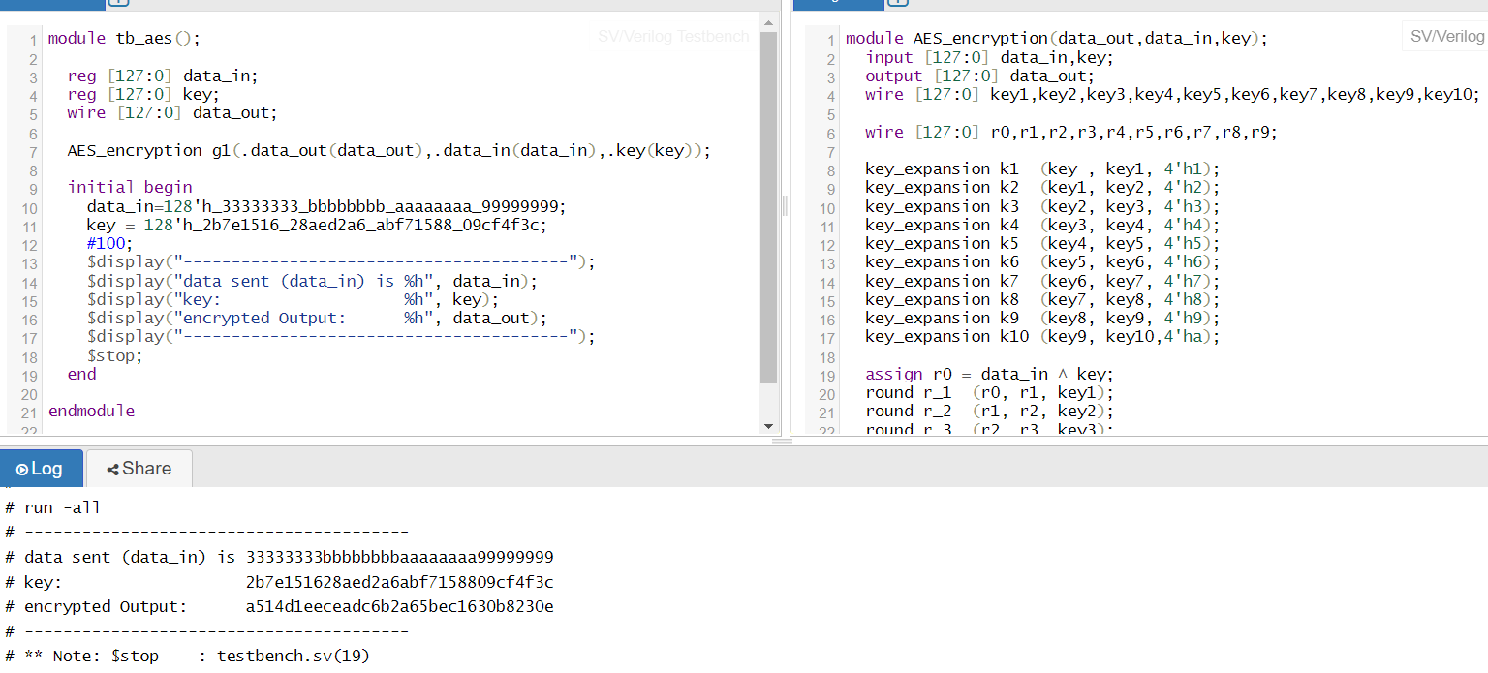

**Testbench code for decryption:**

module tb_aes();

reg [127:0] data_in;

reg [127:0] key;

wire [127:0] data_out;

AES_decryption g3(.data_out(data_out),.data_in(data_in),.key(key));

initial begin

data_in=128'ha514d1eeceadc6b2a65bec1630b8230e;//output at encryption stage

key = 128'h2b7e151628aed2a6abf7158809cf4f3c;

#100;

$display("------------------------------------------------------");

$display("encrypted data (data_in) is %h", data_in);

$display("key: %h", key);

$display("decrypted Output: %h", data_out);

$display("------------------------------------------------------");

$stop;

end

Endmodule

RESULTS:

